#
# 20171117
# One day one of Inter cards became not working.
#

# Block device /dev/nvme0 was absent.
# After cycle power of and on via iDRAC, this block device became visible.
#
# This issue was resolved by Mangasev Alan.
# Was opened case at Dell technical support website.

# How it looks like.

[root@ds-gp-prd-sdw35 ~]# less /var/log/messages
...
Nov 17 10:12:26 sdw35 kernel: nvme 0000:04:00.0: Aborting I/O 0 QID 5
Nov 17 10:12:26 sdw35 kernel: nvme 0000:04:00.0: Aborting I/O 1 QID 5
Nov 17 10:12:26 sdw35 kernel: nvme 0000:04:00.0: Aborting I/O 0 QID 11
Nov 17 10:12:26 sdw35 kernel: nvme 0000:04:00.0: Aborting I/O 0 QID 20
Nov 17 10:12:28 sdw35 mfsmount[5358]: write file error, inode: 2564155, index: 4 - Timeout after 74665 ms (Timeout)(try counter: 1)
Nov 17 10:12:37 sdw35 mfsmount[5358]: write file error, inode: 2564769, index: 0 - Timeout after 66651 ms (Timeout)(try counter: 1)
Nov 17 10:12:46 sdw35 mfsmount[5358]: write file error, inode: 2558587, index: 8 - Timeout after 60824 ms (Timeout)(try counter: 1)
Nov 17 10:13:26 sdw35 kernel: nvme 0000:04:00.0: I/O 4 QID 0 timeout, reset controller
Nov 17 10:13:47 sdw35 mfsmount[5358]: write file error, inode: 2558587, index: 9 - Timeout after 59300 ms (Timeout)(try counter: 1)
Nov 17 10:14:15 sdw35 kernel: INFO: task xfslogd/10:4417 blocked for more than 120 seconds.
Nov 17 10:14:15 sdw35 kernel: Not tainted 2.6.32-696.el6.x86_64 #1
Nov 17 10:14:15 sdw35 kernel: "echo 0 > /proc/sys/kernel/hung_task_timeout_secs" disables this message.
Nov 17 10:14:15 sdw35 kernel: xfslogd/10 D 000000000000000a 0 4417 2 0x00000000
Nov 17 10:14:15 sdw35 kernel: ffff88283737faa0 0000000000000046 ffff8828377e52c0 ffff88283aae4040
Nov 17 10:14:15 sdw35 kernel: ffff88283737fa20 ffffffffa006a981 ffff882836dc0000 ffff882836dc0038
Nov 17 10:14:15 sdw35 kernel: 0000000000000000 ffff8828377e52c0 ffff88283aae45f8 ffff88283737ffd8
Nov 17 10:14:15 sdw35 kernel: Call Trace:
Nov 17 10:14:15 sdw35 kernel: [<ffffffffa006a981>] ? nvme_submit_iod+0x81/0x240 [nvme]
Nov 17 10:14:15 sdw35 kernel: [<ffffffff8154b5b5>] schedule_timeout+0x215/0x2e0
Nov 17 10:14:15 sdw35 kernel: [<ffffffff8127d6d0>] ? generic_make_request+0x240/0x5a0
Nov 17 10:14:15 sdw35 kernel: [<ffffffff81130cd5>] ? mempool_alloc_slab+0x15/0x20
Nov 17 10:14:15 sdw35 kernel: [<ffffffff8154b213>] wait_for_common+0x123/0x180
Nov 17 10:14:15 sdw35 kernel: [<ffffffff8106c480>] ? default_wake_function+0x0/0x20
Nov 17 10:14:15 sdw35 kernel: [<ffffffff8127daa0>] ? submit_bio+0x70/0x120
...
Nov 17 10:14:15 sdw35 kernel: [<ffffffff8109f9d0>] ? worker_thread+0x0/0x2a0
Nov 17 10:14:15 sdw35 kernel: [<ffffffff810a63ae>] kthread+0x9e/0xc0
Nov 17 10:14:15 sdw35 kernel: [<ffffffff8100c28a>] child_rip+0xa/0x20
Nov 17 10:14:15 sdw35 kernel: [<ffffffff810a6310>] ? kthread+0x0/0xc0
Nov 17 10:14:15 sdw35 kernel: [<ffffffff8100c280>] ? child_rip+0x0/0x20
Nov 17 10:14:15 sdw35 kernel: INFO: task xfssyncd/nvme0n:4625 blocked for more than 120 seconds.
Nov 17 10:14:15 sdw35 kernel: Not tainted 2.6.32-696.el6.x86_64 #1
Nov 17 10:14:15 sdw35 kernel: "echo 0 > /proc/sys/kernel/hung_task_timeout_secs" disables this message.
Nov 17 10:14:15 sdw35 kernel: xfssyncd/nvme D 0000000000000007 0 4625 2 0x00000000
Nov 17 10:14:15 sdw35 kernel: ffff88283b99bb50 0000000000000046 0000000000000000 ffffffffa0350bb8
Nov 17 10:14:15 sdw35 kernel: ffff88502c3251e0 ffff883e0be4f038 0000cb986c501b0d ffff883e0be4f000
Nov 17 10:14:15 sdw35 kernel: ffff88283b99bb30 000000010d508268 ffff88283bc2dad8 ffff88283b99bfd8
Nov 17 10:14:15 sdw35 kernel: Call Trace:
Nov 17 10:14:15 sdw35 kernel: [<ffffffffa0350bb8>] ? xfs_iextents_copy+0x68/0xc0 [xfs]
Nov 17 10:14:15 sdw35 kernel: [<ffffffff8154b5b5>] schedule_timeout+0x215/0x2e0
Nov 17 10:14:15 sdw35 kernel: [<ffffffff8154b213>] wait_for_common+0x123/0x180
Nov 17 10:14:15 sdw35 kernel: [<ffffffff8106c480>] ? default_wake_function+0x0/0x20
...
Nov 17 10:14:47 sdw35 kernel: nvme 0000:04:00.0: Device not ready; aborting reset
...

# It helps us to identify this nvme card as Inter (not as HGST).
[root@ds-gp-prd-sdw35 ~]# lspci -v -s $(lspci | grep -ie ssd | awk '{print $1}')
04:00.0 Non-Volatile memory controller: Intel Corporation PCIe Data Center SSD (rev 01) (prog-if 02 [NVM Express])
Subsystem: Intel Corporation Device 00e4
Flags: bus master, fast devsel, latency 0, IRQ 42
Memory at 96100000 (64-bit, non-prefetchable) [size=16K]
Expansion ROM at 91d00000 [disabled] [size=64K]
Capabilities: [40] Power Management version 3
Capabilities: [50] MSI-X: Enable+ Count=32 Masked-
Capabilities: [60] Express Endpoint, MSI 00
Capabilities: [100] Advanced Error Reporting
Capabilities: [150] Virtual Channel
Capabilities: [180] Power Budgeting <?>
Capabilities: [190] Alternative Routing-ID Interpretation (ARI)
Capabilities: [270] Device Serial Number 55-cd-2e-41-4d-4e-e3-2e
Capabilities: [2a0] #19
Kernel driver in use: nvme
Kernel modules: nvme

[root@ds-gp-prd-sdw35 ~]#

# Below I use special utiltiy to see state of this Intel NVMe card.
[root@ds-gp-prd-sdw35 ~]# isdct show -intelssd

- Intel SSD DC P3700 Series PHFT6424006P2P0EGN -

Bootloader : 8B1B0133
DevicePath : /dev/nvme0
DeviceStatus : Selected drive is in a disable logical state.
Firmware : 8DV1DP05
FirmwareUpdateAvailable : Please contact Intel Customer Support for further assistance at the following website: http://www.intel.com/go/ssdsupport.
Index : 0
ModelNumber : INTEL SSDPEDMD020T4D HHHL NVMe 2000GB
ProductFamily : Intel SSD DC P3700 Series
SerialNumber : PHFT6424006P2P0EGN

[root@ds-gp-prd-sdw35 ~]#

[root@ds-gp-prd-sdw35 ~]# isdct show -a -intelssd

- Intel SSD DC P3700 Series PHFT6424006P2P0EGN -

AggregationThreshold : Selected drive is in a disable logical state.
AggregationTime : Selected drive is in a disable logical state.
ArbitrationBurst : Selected drive is in a disable logical state.
Bootloader : 8B1B0133
CoalescingDisable : Selected drive is in a disable logical state.
DevicePath : /dev/nvme0
DeviceStatus : Selected drive is in a disable logical state.
DirectivesSupported : False
DynamicMMIOEnabled : The selected drive does not support this feature.
EnduranceAnalyzer : Selected drive is in a disable logical state.
ErrorString : *XASSERT_405574F8 00
Firmware : 8DV1DP05
FirmwareUpdateAvailable : Please contact Intel Customer Support for further assistance at the following website: http://www.intel.com/go/ssdsupport.
HighPriorityWeightArbitration : Selected drive is in a disable logical state.
IOCompletionQueuesRequested : Selected drive is in a disable logical state.
IOSubmissionQueuesRequested : Selected drive is in a disable logical state.
Index : 0
Intel : True
IntelGen3SATA : False
IntelNVMe : True
InterruptVector : Selected drive is in a disable logical state.
LatencyTrackingEnabled : Selected drive is in a disable logical state.
LowPriorityWeightArbitration : Selected drive is in a disable logical state.
MediumPriorityWeightArbitration : Selected drive is in a disable logical state.
ModelNumber : INTEL SSDPEDMD020T4D HHHL NVMe 2000GB
NVMeControllerID : 0
NVMeMajorVersion : 1
NVMeMinorVersion : 0
NVMePowerState : Selected drive is in a disable logical state.
NVMeTertiaryVersion : 0
NamespaceId : 4294967295
NamespaceManagementSupported : False
NativeMaxLBA : Selected drive is in a disable logical state.
NumErrorLogPageEntries : 63
OEM : Dell
PCILinkGenSpeed : 3
PCILinkWidth : 4
PLITestTimeInterval : The selected drive does not support this feature.
PhySpeed : The selected drive does not support this feature.
PhysicalSectorSize : The selected drive does not support this feature.
PowerGovernorAveragePower : Selected drive is in a disable logical state.
PowerGovernorBurstPower : Selected drive is in a disable logical state.
PowerGovernorMode : Selected drive is in a disable logical state.
Product : Fultondale
ProductFamily : Intel SSD DC P3700 Series
ProductProtocol : NVME
ReadErrorRecoveryTimer : Selected drive is in a disable logical state.
SMARTEnabled : True
SMARTHealthCriticalWarningsConfiguration : Selected drive is in a disable logical state.
SMBusAddress : Selected drive is in a disable logical state.
SectorSize : 512
SerialNumber : PHFT6424006P2P0EGN
TCGSupported : False
TempThreshold : Selected drive is in a disable logical state.
TemperatureLoggingInterval : The selected drive does not support this feature.
TimeLimitedErrorRecovery : Selected drive is in a disable logical state.
TrimSupported : True
VolatileWriteCacheEnabled : Selected drive is in a disable logical state.
WriteAtomicityDisableNormal : Selected drive is in a disable logical state.
WriteCacheReorderingStateEnabled : The selected drive does not support this feature.
WriteCacheState : The selected drive does not support this feature.
WriteErrorRecoveryTimer : Selected drive is in a disable logical state.

[root@ds-gp-prd-sdw35 ~]#

# P3700
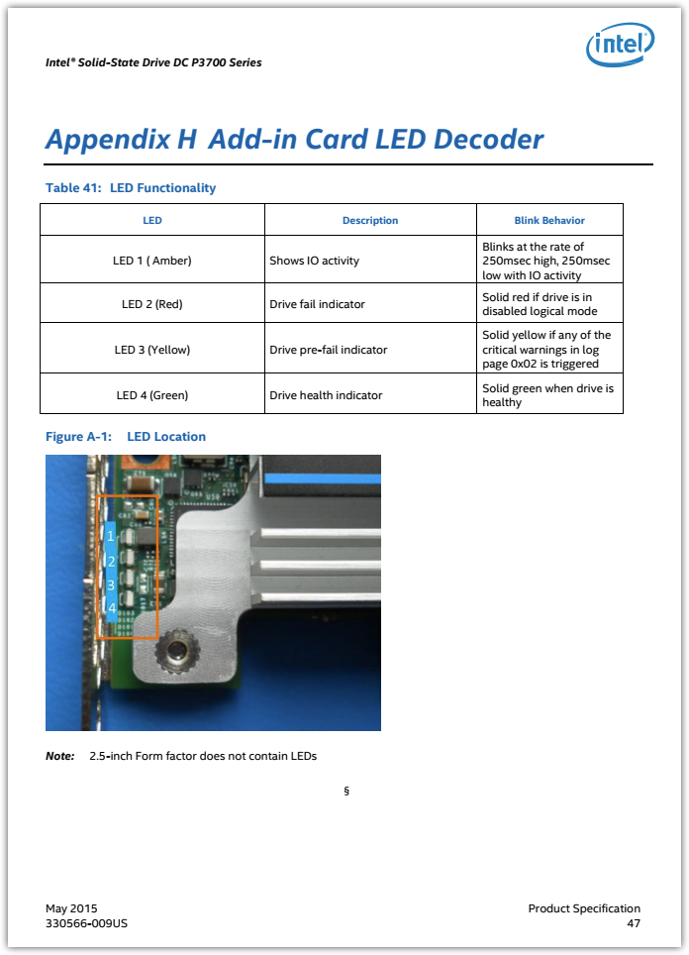

# 20170815
# This is several ways to use utility for Intel PCIe SSD card.
#

[root@m1-2-gp-prd-sdw1 ~]# yum localinstall /tmp/isdct-3.0.6.400-17.x86_64.rpm

[root@m1-2-gp-prd-sdw1 ~]# isdct show -intelssd

- Intel SSD DC P3700 Series PHFT642400KL2P0EGN -

Bootloader : 8B1B0133
DevicePath : /dev/nvme0n1
DeviceStatus : Healthy
Firmware : 8DV1DP05
FirmwareUpdateAvailable : Please contact your Intel representative about firmware update for this drive.
Index : 0
ModelNumber : INTEL SSDPEDMD020T4D HHHL NVMe 2000GB
ProductFamily : Intel SSD DC P3700 Series
SerialNumber : PHFT642400KL2P0EGN

[root@m1-2-gp-prd-sdw1 ~]#

[root@m1-2-gp-prd-sdw1 ~]# isdct show -a -intelssd

- Intel SSD DC P3700 Series PHFT642400KL2P0EGN -

AggregationThreshold : 0
AggregationTime : 0
ArbitrationBurst : 0
Bootloader : 8B1B0133
CoalescingDisable : 1
DevicePath : /dev/nvme0n1
DeviceStatus : Healthy
DirectivesSupported : False
DynamicMMIOEnabled : The selected drive does not support this feature.
EndToEndDataProtCapabilities : 17
EnduranceAnalyzer : Media Workload Indicators have reset values. Run 60+ minute workload prior to running the endurance analyzer.
ErrorString :
Firmware : 8DV1DP05
FirmwareUpdateAvailable : Please contact your Intel representative about firmware update for this drive.
HighPriorityWeightArbitration : 0
IOCompletionQueuesRequested : 30
IOSubmissionQueuesRequested : 30
Index : 0
Intel : True
IntelGen3SATA : False
IntelNVMe : True
InterruptVector : 0
LBAFormat : 0
LatencyTrackingEnabled : False
LowPriorityWeightArbitration : 0
MaximumLBA : 3907029167
MediumPriorityWeightArbitration : 0
MetadataSetting : 0
ModelNumber : INTEL SSDPEDMD020T4D HHHL NVMe 2000GB
NVMeControllerID : 0
NVMeMajorVersion : 1
NVMeMinorVersion : 0
NVMePowerState : 0
NVMeTertiaryVersion : 0
NamespaceId : 1
NamespaceManagementSupported : False
NativeMaxLBA : 3907029167
NumErrorLogPageEntries : 63
NumLBAFormats : 6
OEM : Dell
PCILinkGenSpeed : 3
PCILinkWidth : 4
PLITestTimeInterval : The selected drive does not support this feature.
PhySpeed : The selected drive does not support this feature.
PhysicalSectorSize : The selected drive does not support this feature.
PhysicalSize : 2000398934016
PowerGovernorAveragePower : The desired feature is not supported.
PowerGovernorBurstPower : The desired feature is not supported.
PowerGovernorMode : 0 25W
Product : Fultondale
ProductFamily : Intel SSD DC P3700 Series
ProductProtocol : NVME
ProtectionInformation : 0
ProtectionInformationLocation : 0
ReadErrorRecoveryTimer : Device does not support this command set.
SMARTEnabled : True
SMARTHealthCriticalWarningsConfiguration : 0
SMBusAddress : 128
SectorSize : 512
SerialNumber : PHFT642400KL2P0EGN
TCGSupported : False
TempThreshold : 85
TemperatureLoggingInterval : The selected drive does not support this feature.
TimeLimitedErrorRecovery : 0
TrimSupported : True
VolatileWriteCacheEnabled : False
WriteAtomicityDisableNormal : 0
WriteCacheReorderingStateEnabled : The selected drive does not support this feature.
WriteCacheState : The selected drive does not support this feature.
WriteErrorRecoveryTimer : Device does not support this command set.

[root@m1-2-gp-prd-sdw1 ~]#

#
# 20170815
# We can use for nagios checks, for Intel PCIe SSD cards, same script as we use for GHST PCIe SSD cards.

[root@m1-2-gp-prd-sdw1 ~]# cat /etc/nrpe.d/check_nvme.cfg
command[check_nvme]=/usr/lib64/nagios/plugins/check_nvme.sh
[root@m1-2-gp-prd-sdw1 ~]# /usr/lib64/nagios/plugins/check_nvme.sh
OK - nvme0n1
[root@m1-2-gp-prd-sdw1 ~]#

From: Belogrud Sergey Vladimirovich
Sent: Tuesday, August 15, 2017 12:45 PM
To: Chernyh Aleksandr Vladimirovich <a.chernyh@tinkoff.ru>
Subject: Утилита для PCIe SSD карт Intel 3700

Добрый день.

https://downloadcenter.intel.com/product/80095/SSD-Software

Сейчас rpm-пакет лежит здесь.
[root@m1-2-gp-prd-mdw 20170814-1720]# pwd ; ls isdct-3.0.6.400-17.x86_64.rpm
/root/work/20170814-1720
isdct-3.0.6.400-17.x86_64.rpm
[root@m1-2-gp-prd-mdw 20170814-1720]#

[root@m1-2-gp-prd-sdw1 ~]# yum localinstall /tmp/isdct-3.0.6.400-17.x86_64.rpm

[root@m1-2-gp-prd-sdw1 ~]# isdct show -intelssd

- Intel SSD DC P3700 Series PHFT642400KL2P0EGN -

Bootloader : 8B1B0133
DevicePath : /dev/nvme0n1
DeviceStatus : Healthy
Firmware : 8DV1DP05
FirmwareUpdateAvailable : Please contact your Intel representative about firmware update for this drive.
Index : 0
ModelNumber : INTEL SSDPEDMD020T4D HHHL NVMe 2000GB
ProductFamily : Intel SSD DC P3700 Series
SerialNumber : PHFT642400KL2P0EGN

[root@m1-2-gp-prd-sdw1 ~]#

Имеющаяся утилита и скрипт проверки с PCIe SSD картами работает тоже.
[root@m1-2-gp-prd-sdw1 ~]# cat /etc/nrpe.d/check_nvme.cfg
command[check_nvme]=/usr/lib64/nagios/plugins/check_nvme.sh
[root@m1-2-gp-prd-sdw1 ~]# /usr/lib64/nagios/plugins/check_nvme.sh
OK - nvme0n1
[root@m1-2-gp-prd-sdw1 ~]#

С уважением,

Сергей Белогруд
Старший системный администратор

#
# Here is a nagios script: /usr/lib64/nagios/plugins/check_nvme.sh
#

#!/bin/bash
#
# Simple Nagios check for nvme using nvme-cli
# Author: Sam McLeod https://smcleod.net
#
# Requirements:
# nvme-cli - git clone https://github.com/linux-nvme/nvme-cli
#
# Usage:
# ./check_nvme.sh

DISKS=$(lsblk -e 11,253 -dn -o NAME | grep nvme)
CRIT=false
MESSAGE=""

for DISK in $DISKS ; do
# Check for critical_warning
$(nvme smart-log /dev/$DISK | awk 'FNR == 2 && $3 != 0 {exit 1}')
if [ $? == 1 ]; then
CRIT=true
MESSAGE="$MESSAGE $DISK has critical warning "
fi

# Check media_errors
$(nvme smart-log /dev/$DISK | awk 'FNR == 15 && $3 != 0 {exit 1}')
if [ $? == 1 ]; then
CRIT=true
MESSAGE="$MESSAGE $DISK has media errors "
fi

# Check num_err_log_entries
$(nvme smart-log /dev/$DISK | awk 'FNR == 16 && $3 != 0 {exit 1}')
if [ $? == 1 ]; then
CRIT=true
MESSAGE="$MESSAGE $DISK has errors logged "
fi
done

if [ $CRIT = "true" ]; then
echo "CRITICAL: $MESSAGE"
exit 2
else
echo "OK - $(echo $DISKS | tr -d '\n')"
exit 0
fi

# Alternative nagios scripts.
https://github.com/vorlon/check_nvme/blob/master/check_nvme.sh

https://communities.intel.com/thread/77666

#
# 20170815
# To download drivers or other software.
#
https://downloadcenter.intel.com/product/80095/SSD-Software

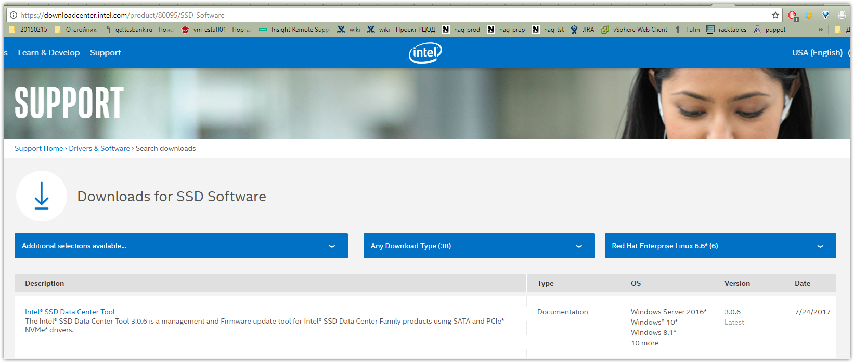

https://downloadcenter.intel.com/download/26970/Intel-SSD-Data-Center-Tool?product=80095

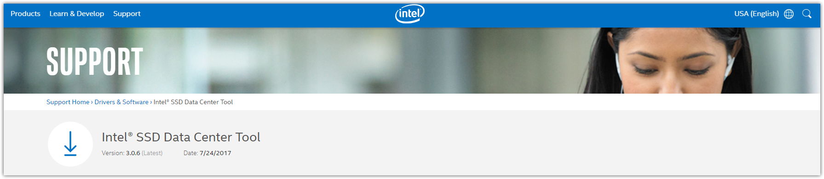
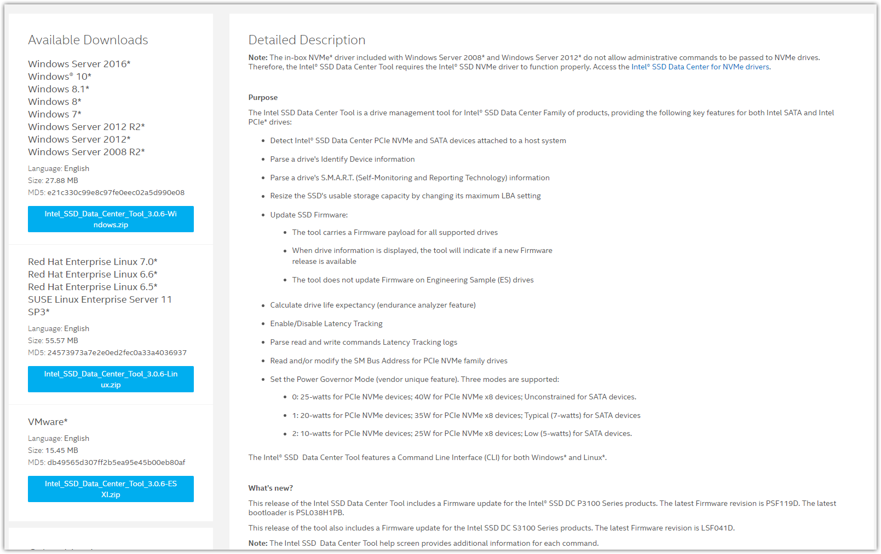
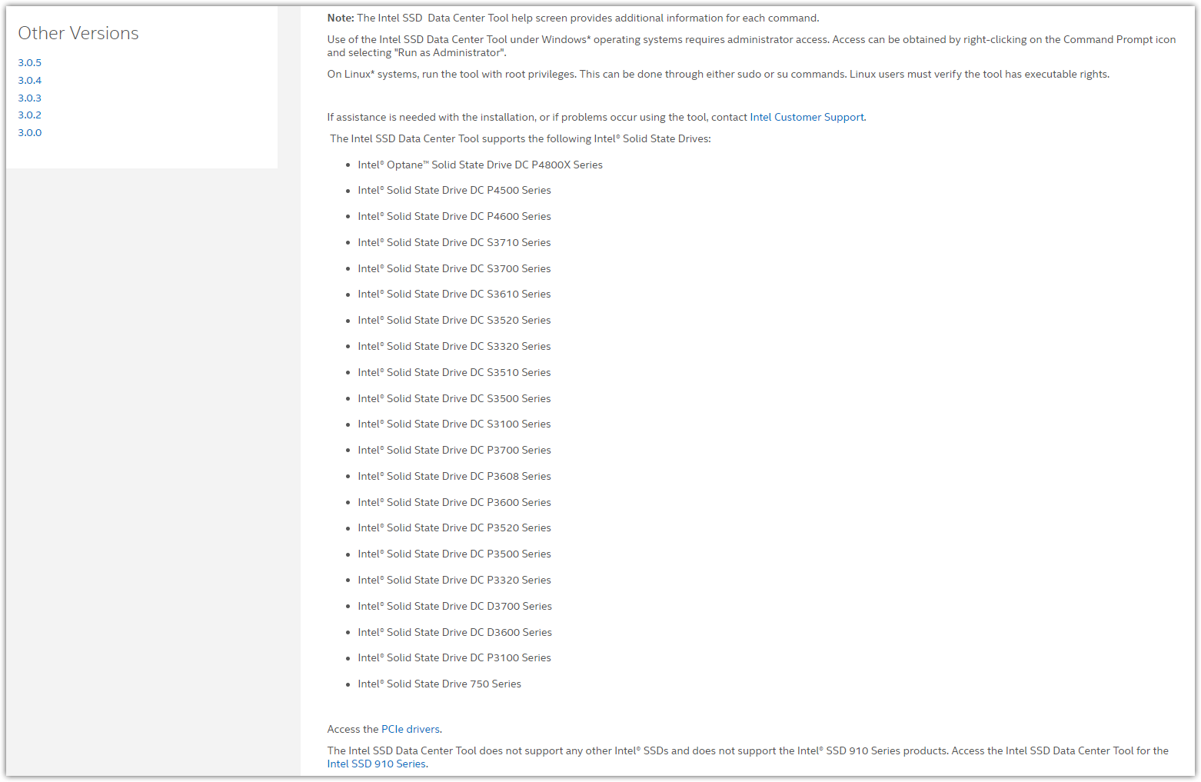
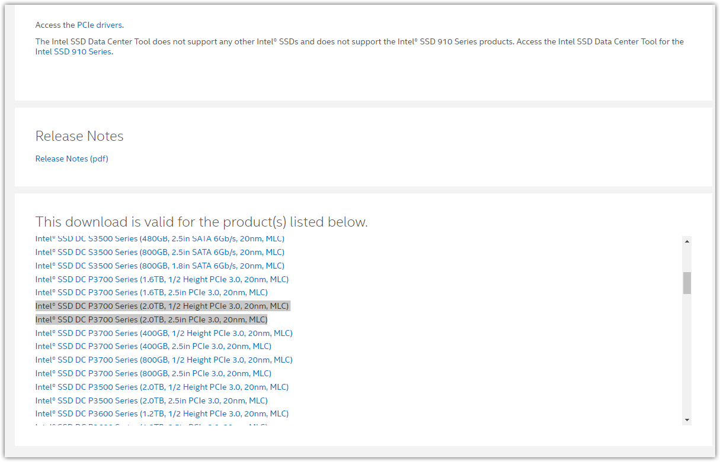

#
# Release Notes pdf document contains follow.
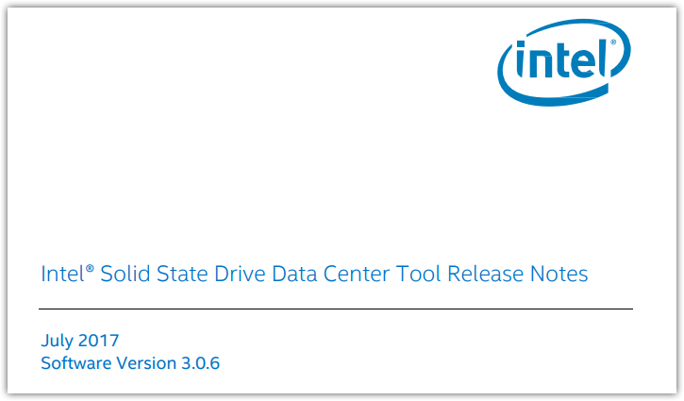
...
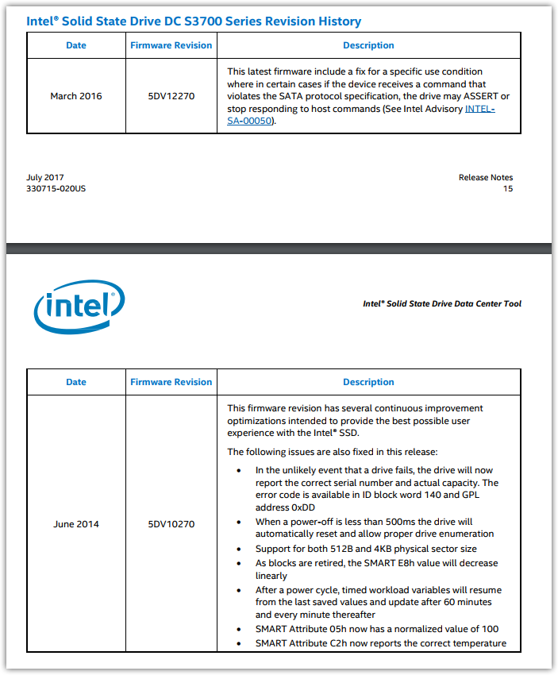

https://www.intel.com/content/www/us/en/products/memory-storage/solid-state-drives/data-center-ssds/dc-p3700-series.html
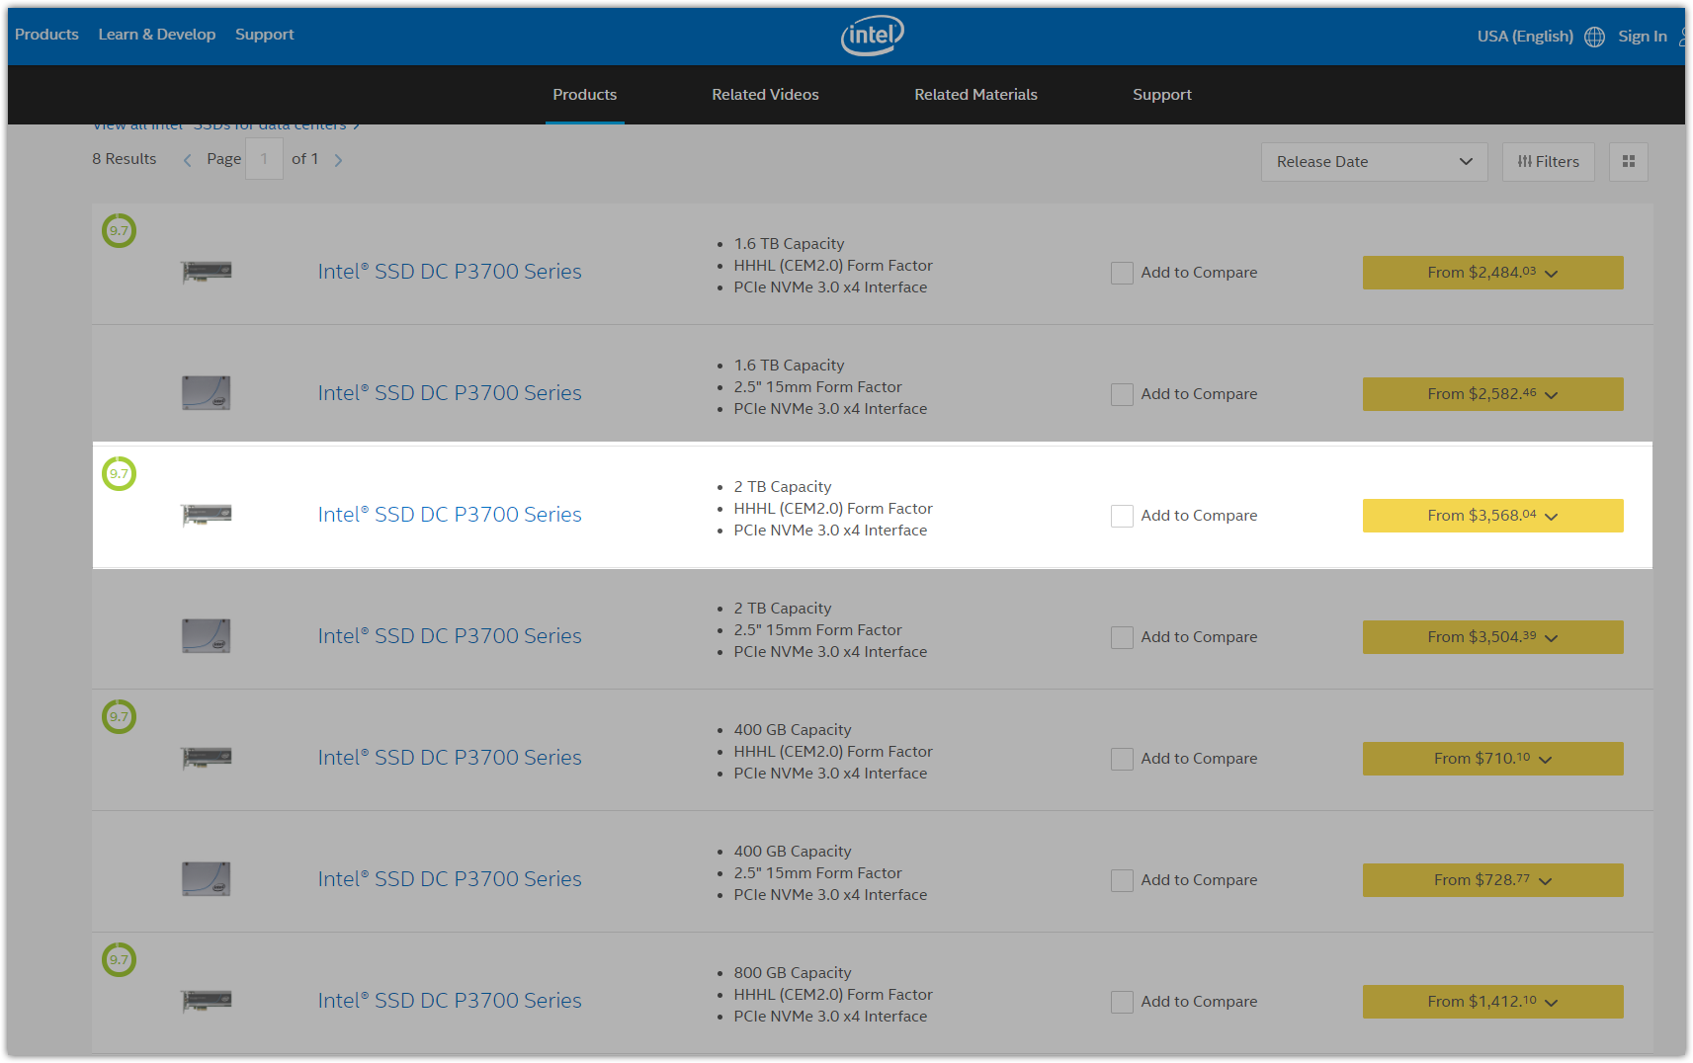

https://www.intel.ru/content/www/ru/ru/solid-state-drives/intel-ssd-dc-family-for-pcie.html
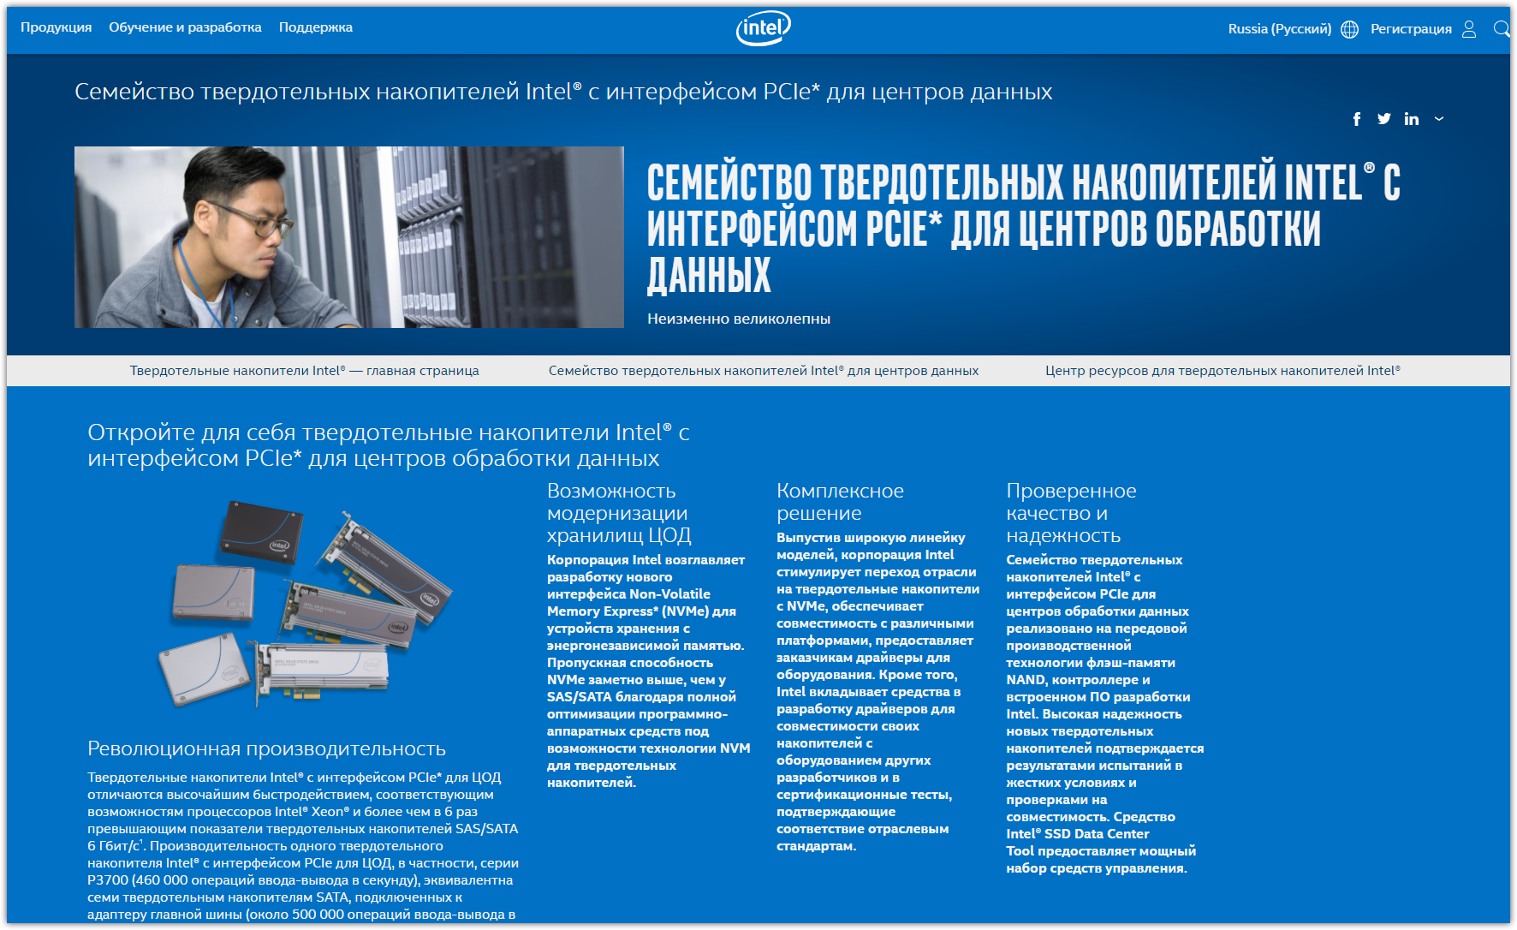

https://www.intel.com/content/www/us/en/products/memory-storage/solid-state-drives/data-center-ssds/dc-p3700-series/dc-p3700-2tb-aic-20nm.html
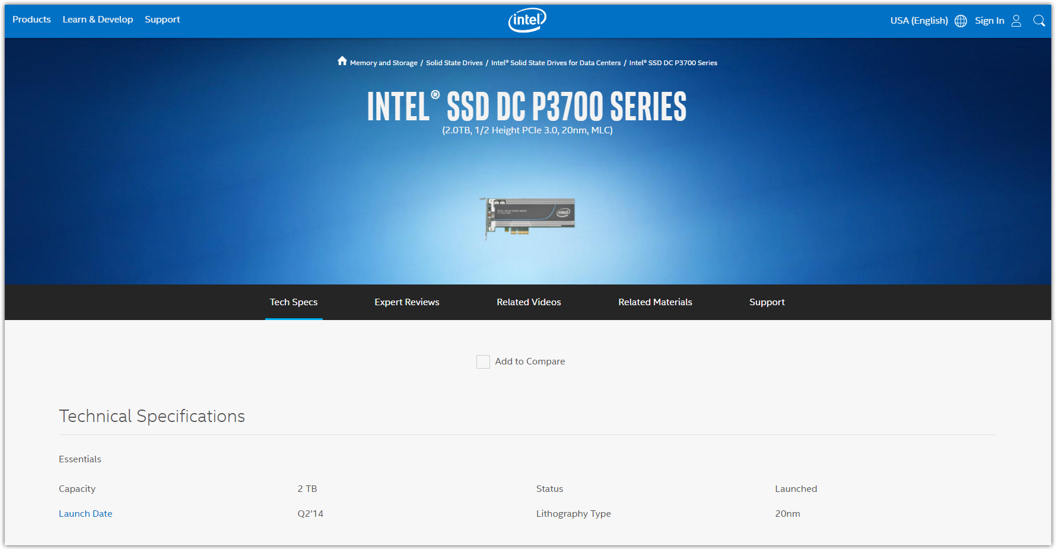
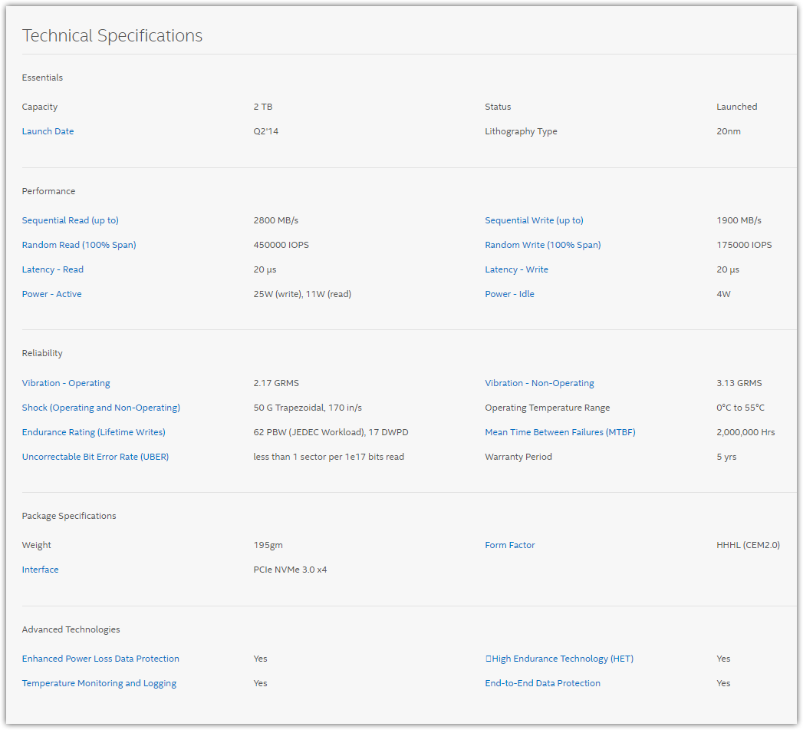
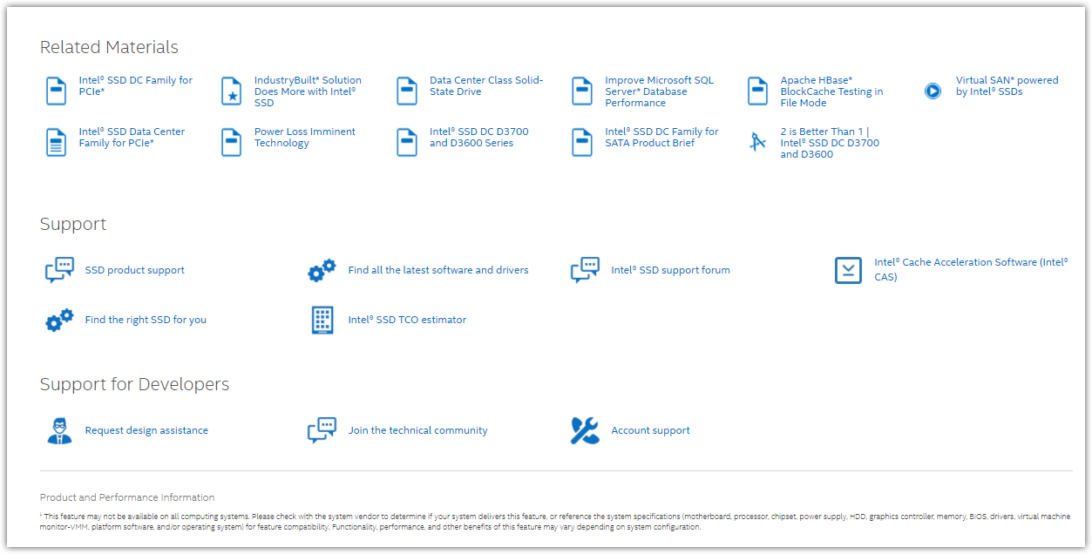

https://downloadcenter.intel.com/ru/download/23931/-Intel-SSD-Data-Center-Tool?product=79624
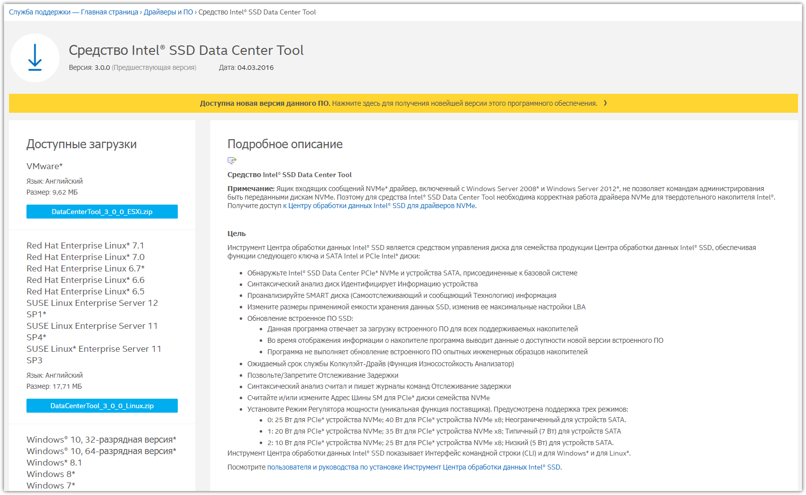

http://www.thg.ru/storage/obzor_intel_ssd_dc_p3700/



